***Project Report***

***PERSONAL EXPENSE TRACKER APPLICATION***

1. **INTRODUCTION**

**1.1 PROJECT OVERVIEW**

In simple words, personal finance entails all the financial decisions and activities that a Finance app makes your life easier by helping you to manage your finances efficiently. A personal finance app will not only help you with budgeting and accounting but also give you helpful insights about money management.

**1.2 PURPOSE**

Also known as expense manager and money manager, an expense tracker is a software or application that helps to keep an accurate record of your money inflow and outflow. Many people in India live on a fixed income, and they find that towards the end of the month they don't have sufficient money to meet their needs

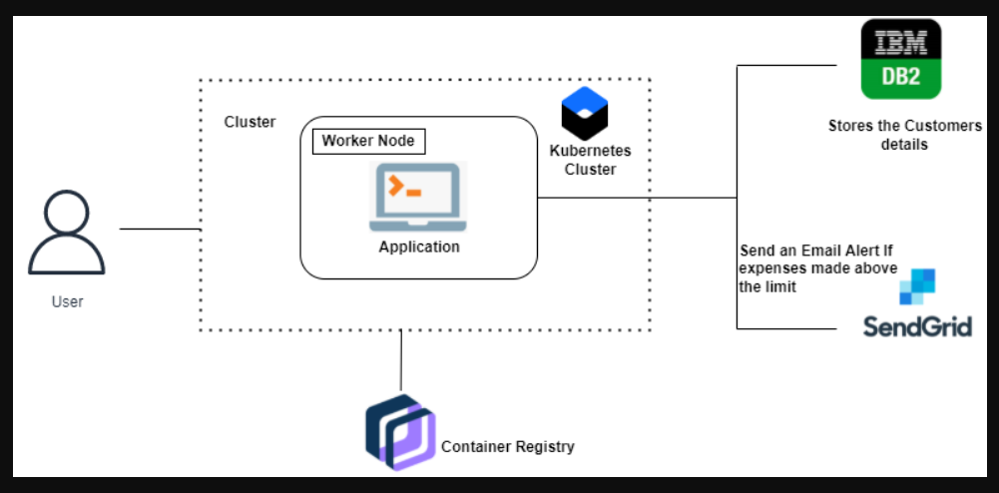

1. **LITERATURE SURVEY**

**2.1 EXISTING PROJECT**

A project that has been accomplished and saved previously

**2.2 REFERENCE**

* <https://vimeo.com/746020190/34e9b4e154>
* https://www.youtube.com/watch?v=Bu6fAlltatA

**2.3 PROBLEM STATEMENT DEFINITION**

It is tough to keep track of all the financial decisions and activities that a person makes. Traditional expense tracking methods are inconvenient and unreliable. So this model helps in solving the traditional method by it’s convenient to digitize the process and by having a personal expense tracker.

**3. IDEATION & PROPOSED SOLUTION**

**3.1 EMPATHY MAP CANVAS**

It’s a collaboration tool means can use to gain a deeper insight into their customers.

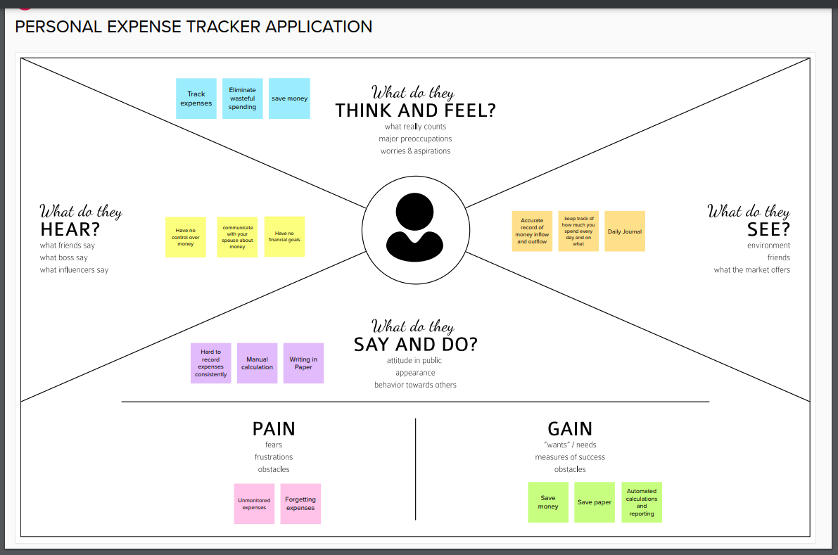

**3.2 IDEATION & BRAINSTORMING**

Technique that is utilized to generate new ideas.

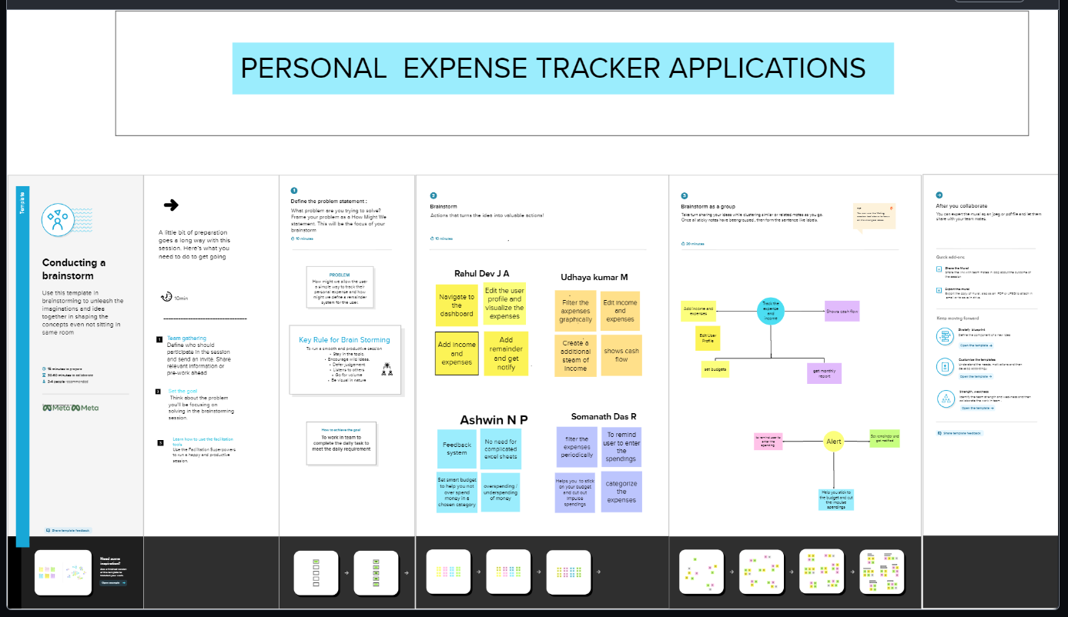

**3.3PROPOSED SOLUTION**

It relates the current solution to a desired result and describe the benefit that accrue.

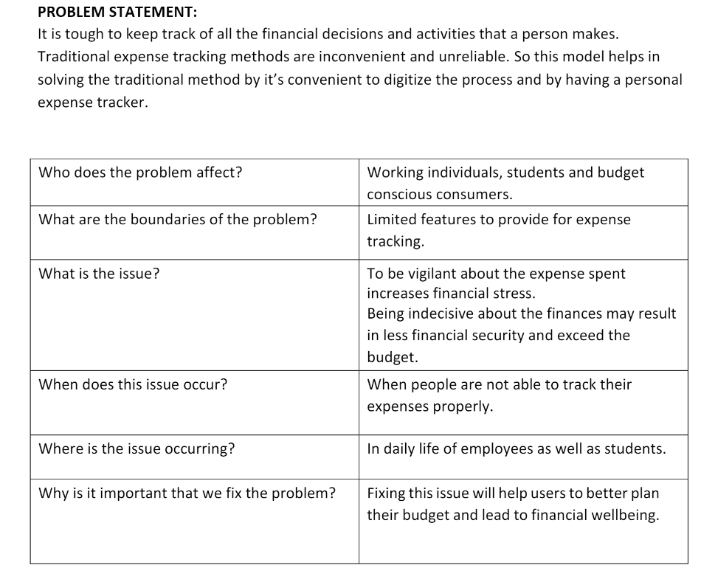

3.4 PROBLEM SOLUTION FIT

For a problem, you have found a solution that fit for the customer’s problem

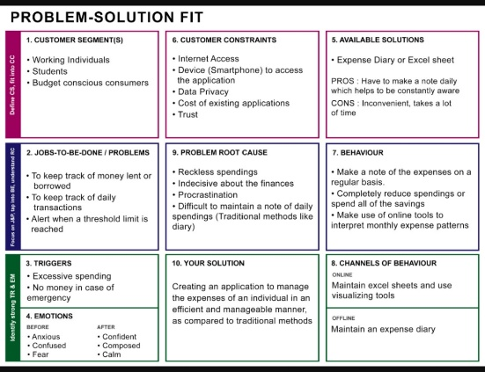

4. REQUIREMENT ANALYSIS

4.1FUCNTIONAL REQUIREMENTS

It defines how the system should need to work

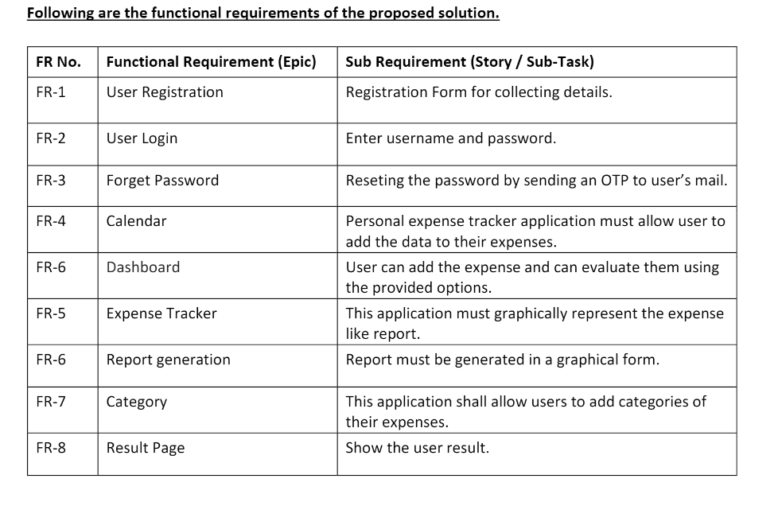

4.2 NON-FUNCTIONAL REQUIREMENTS

It defines how the system should perform in all the cases involved there.

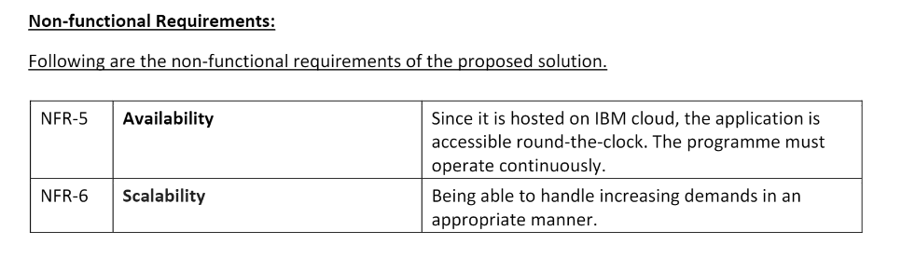

5. PROJECT DESIGN

5.1 DATA FLOW DIAGRAMS

It’s graphical or visual representation using a standardized set of symbols to describe the operations

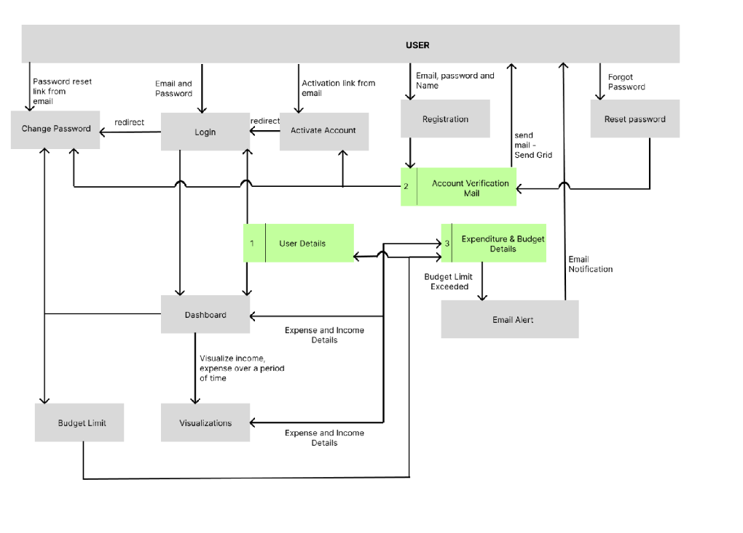

5.2 SOLUTION & TECHNICAL ARCHITECTURE

It’s an architectural description of a specific solutions

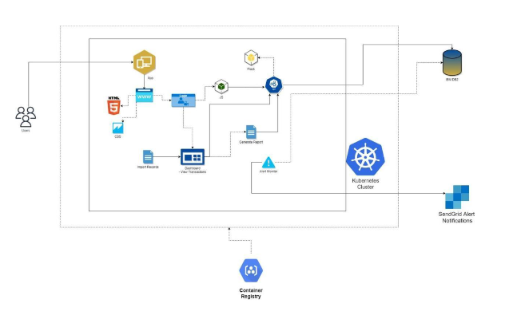

5.3 USER STORIES

it’s an informal, general explanation of a software feature written from the perspective of the end user

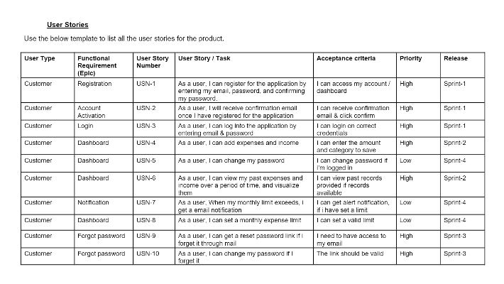

6 PROJECT PLANNING & SCHEDULING

6.1 SPRINT PLANNING & ESTIMATION

It’s an event in scrum that kick off the spring.

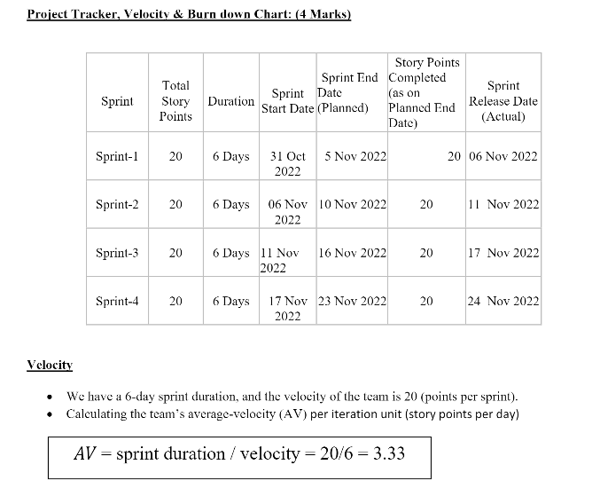

6.2 SPRINT DELIVERY SCHEDULE

It is constraint fixed with each taking not more than two hours for each week of the sprint

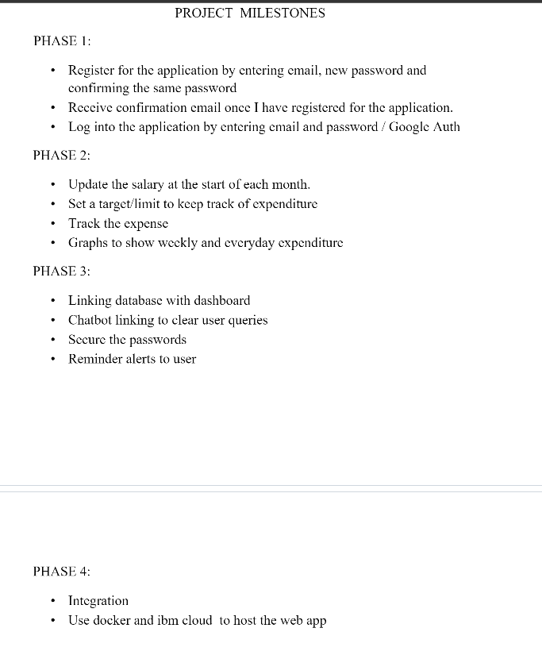

6.3 REPORT FROM JIRA

It’s a part of family of product design to help teams to manage work

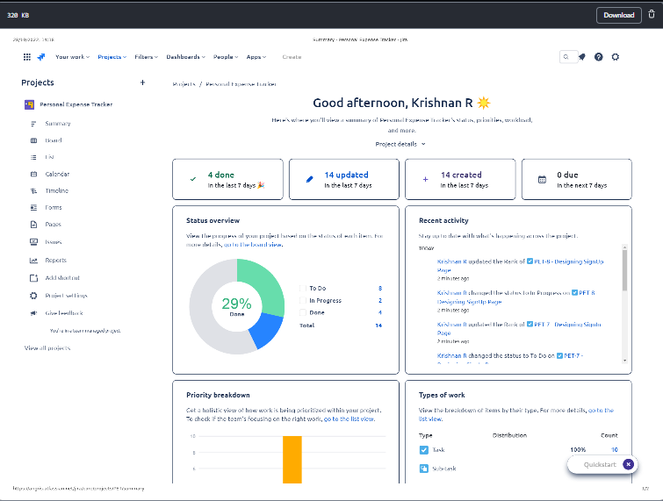

7 CODING & SOLUTION (EXPRESS THE FEATURES ADDED IN THE PROJECT ALONG WITH CODE)

7.1 FEATURE 1:

Here, we added the home page where the user can navigate to registration or login page, where they can hen register and use the features.

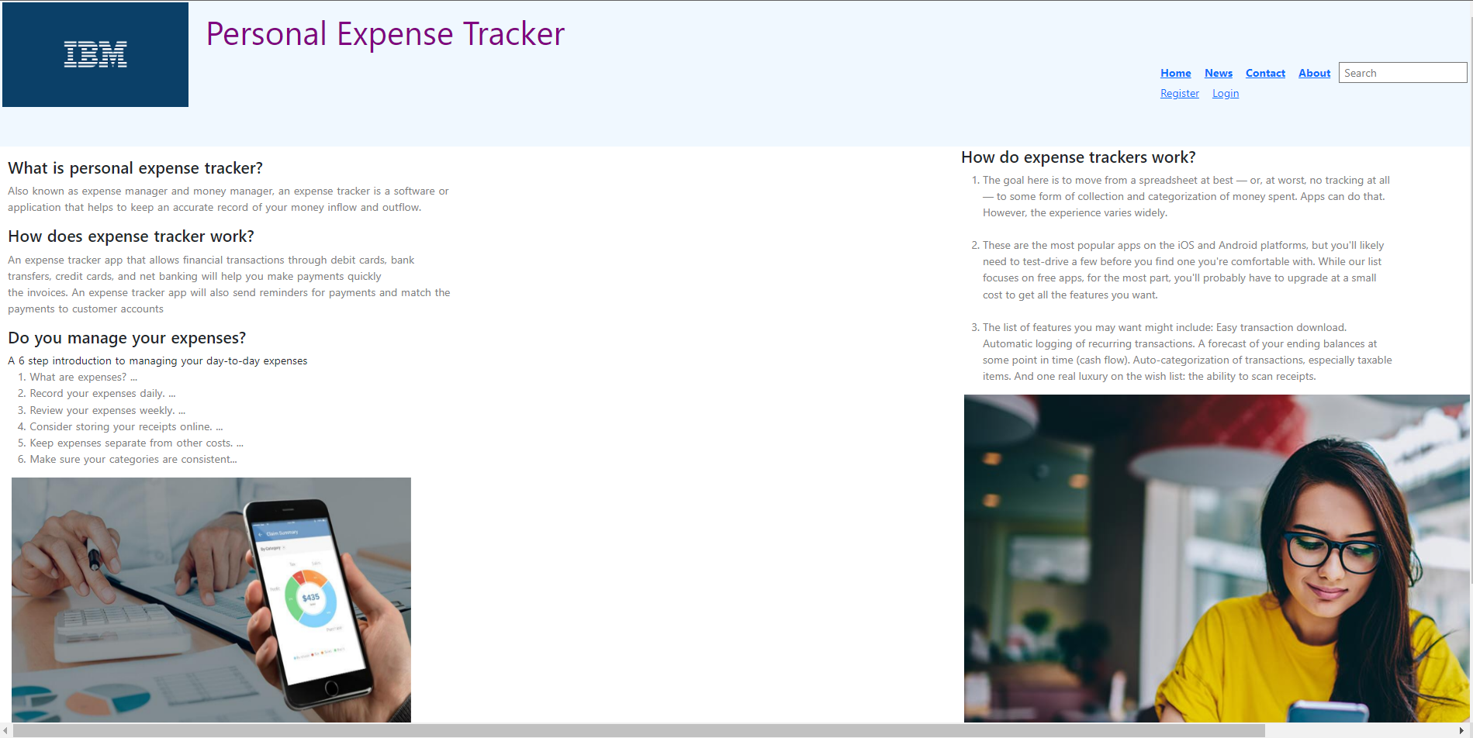 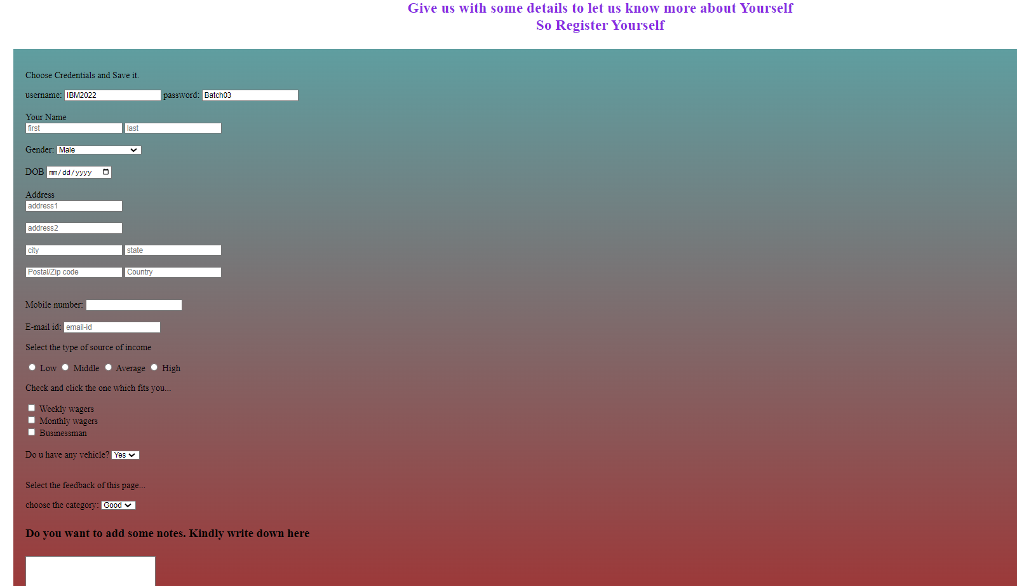

7.2 FEATURE 2

In this, we added the dashboard page where the user can add their expenses. Also we included the Watson Assistant to assist the user

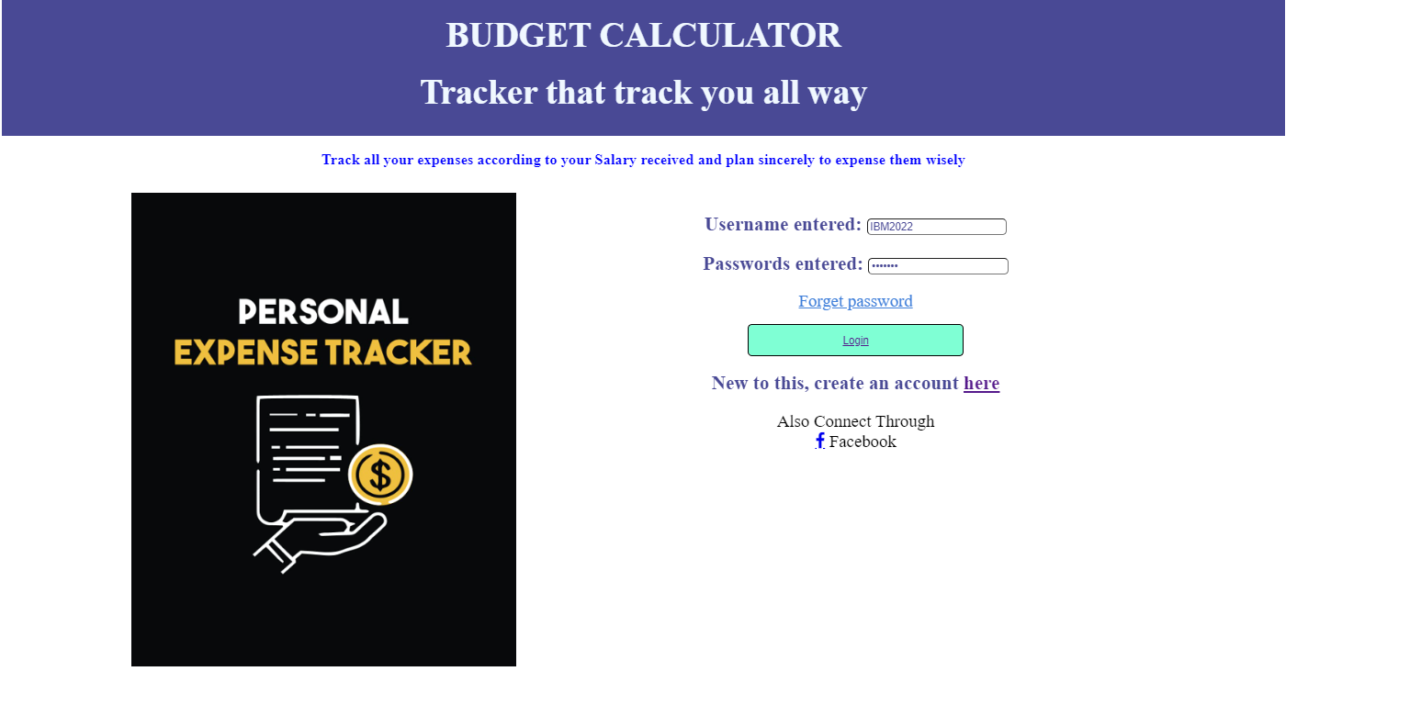

7. 3 DATABASE SCHEMA (IF APPLICABLE)

Here we added the database for the ensuring the connectivity with the database

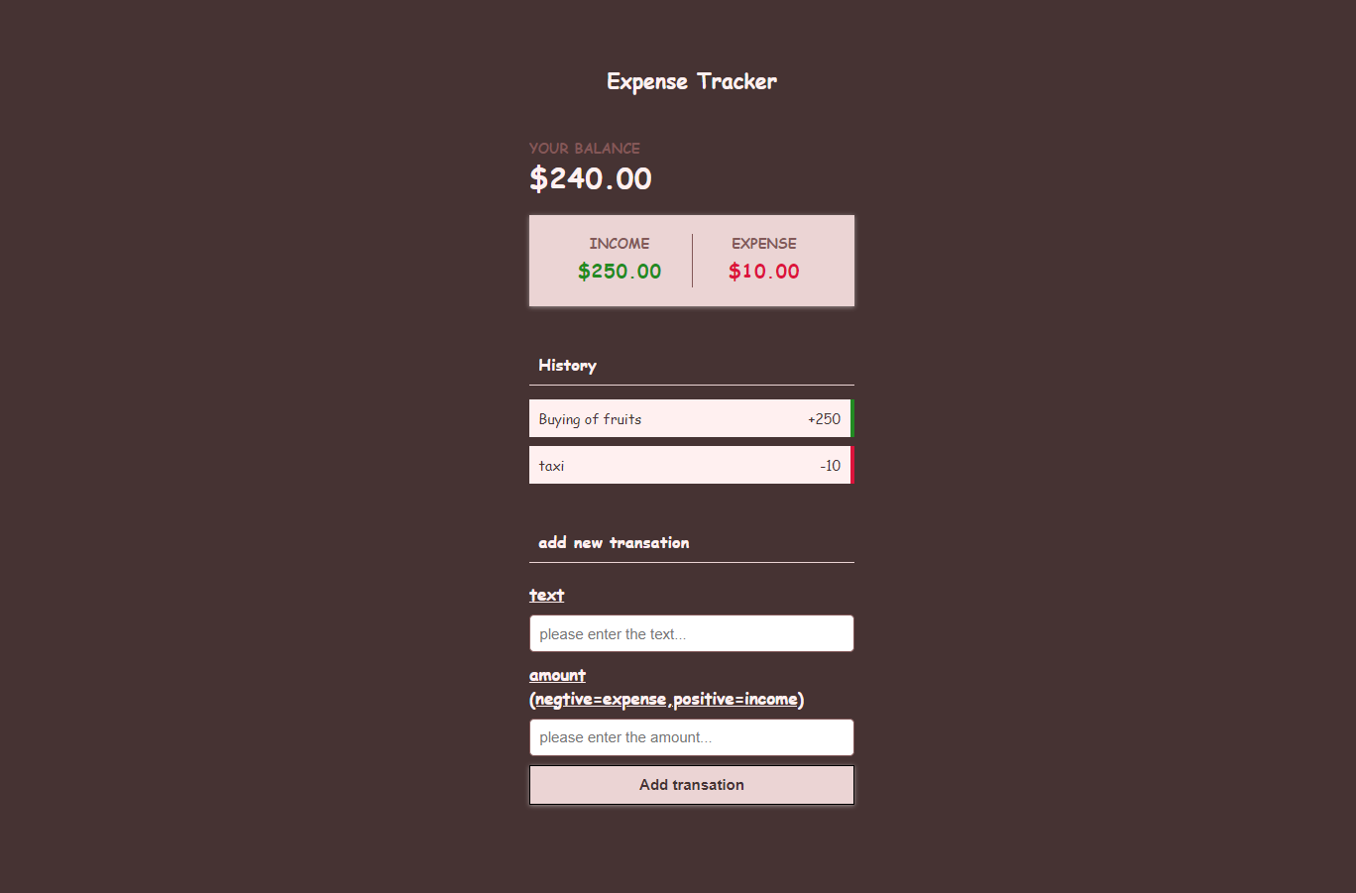

8 TESTING

8.1 TEST CASES

8.2 USER ACCEPTANC TEST

|  |  |  |  |  |  |
| --- | --- | --- | --- | --- | --- |
| **Resolution** | **Severity 1** | **Severity 2** | **Severity 3** | **Severity 4** | **Subtotal** |
| By Design | 0 | 0 | 0 | 0 | 0 |
| Duplicate | 0 | 0 | 0 | 0 | 0 |
| External | 1 | 0 | 0 | 0 | 1 |
| Fixed | 0 | 2 | 0 | 0 | 2 |
| Not Reproduced | 0 | 0 | 0 | 0 | 0 |
| Skipped | 0 | 0 | 0 | 0 | 0 |
| Won't Fix | 0 | 0 | 0 | 0 | 0 |
| Totals | 1 | 2 | 0 | 0 | 3 |

9 RESULTS

9.1 PERFORMANCE METRICS

It’s defined as the figures and data representative of an organization’s action, abilities.

10 ADVANTAGES AND DISADVANTAGES

PROS:

* + It helps you stick to budget
  + tracking your expenses can reveal spending issues
  + it helps you meet your financial objectives
  + Record expenses with pen and paper
  + Make it easier with an app or software

CONS:

* + Determining the right process
  + Feeling constrained
  + Spend more than necessary
  + Finding the time for it
  + Making the right decision
  + Impacting how employee feel
  + Overlooking important factors
  + Having top-level employees do all the planning

11 CONCLUSIONS

The project what we have developed is work more efficient than the other income and expense tracker .The project successfully avoids the manual calculation the income and expense per month .The modules are developed with efficient and also in an attractive manner.

12 FUTURE SCOPE

* The future scope of testing methods and statistics.
* The future scope on the complete redesigning of methodology.

13 APPENDIX

* 1. SOURCE CODE:

https://github.com/IBM-EPBL/IBM-Project-54078-1661588783/tree/main/EXPENSE_TRACKER

* 1. GITHUB & PROJECT DEMO LINK:

https://github.com/IBM-EPBL/IBM-Project-54078-1661588783/tree/main/EXPENSE_TRACKER